Calculating family expenses using Service now

Team ID: NM2025TMID13428
Team Members: 4
Team Leader: AABI E
Team Member1 RESHMA A
Team Member2: BHARANI P
Team Member3: RANJANI N
Problem statement: Many families are struggle to manage monthly spending expenses and this project was used to manage and monitoring the family expenses. The purpose of the project is used to create a simple system for manage family expenses and it make easier to control spending their money Then it helps to improve financial planning milestones.
Objective: To design and implement a solution within ServiceNow that enables users to track, manage, and analyze family expenses efficiently, providing better insights into spending habits, budgeting, and financial planning.
Skills: Developed a custom expense tracking application in ServiceNow to manage and analyze family expenses. Utilized custom tables and forms for data entry, automated workflows using Flow Designer, and created interactive dashboards for visualizing spending trends. Implemented client scripts and business rules for data validation and process automation, while ensuring data privacy through proper role-based access controls.
TASK INITIATION

Milestone 1: Navigate to the ServiceNow.

Activity 1: Setting up ServiceNow Instance

Open service Now
- Sign up for a developer account on the ServiceNow Developer site “https://developer.servicenow.com”.
- Once logged in, navigate to the "Personal Developer Instance" section.
- Click on "Request Instance" to create a new ServiceNow instance.
- Fill out the required information and submit the request.
- You'll receive an email with the instance details once it's ready.
- Log in to your ServiceNow instance using the provided credentials.
- Now you will navigate to the ServiceNow.
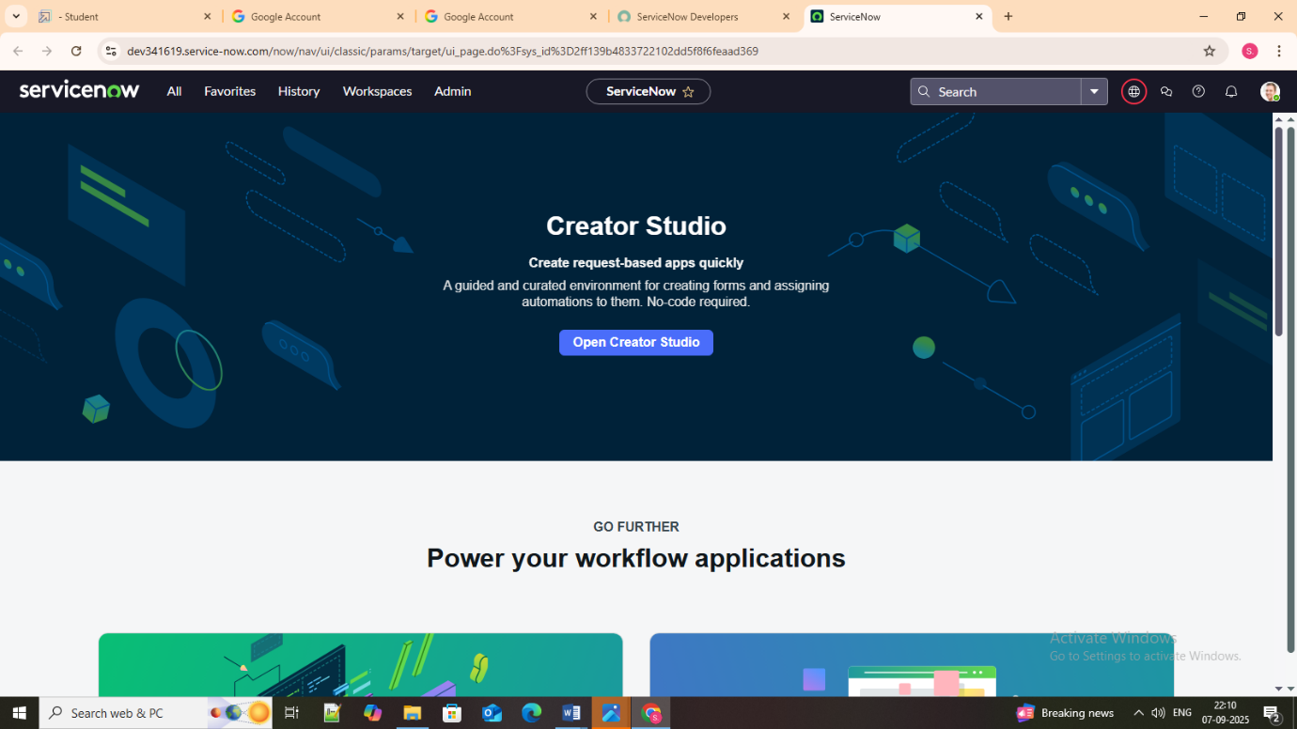

Milestone 2: Update set

Activity 1: Creation of New Update Set

1. Go to All >> In the filter search for Local Update set > click on New.
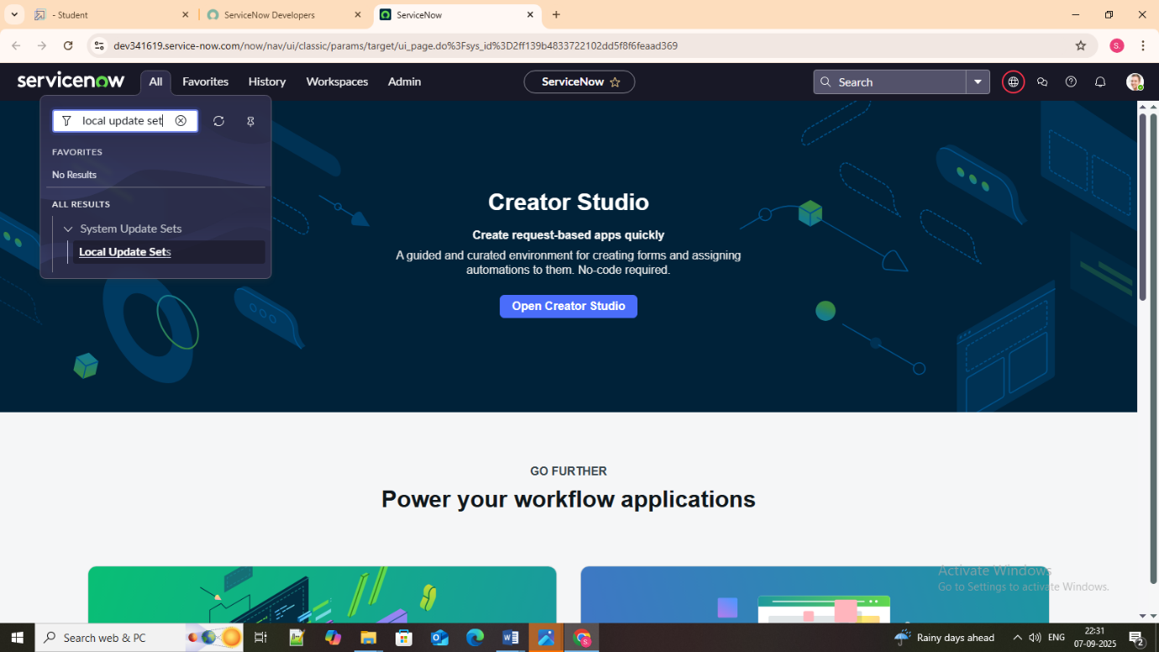

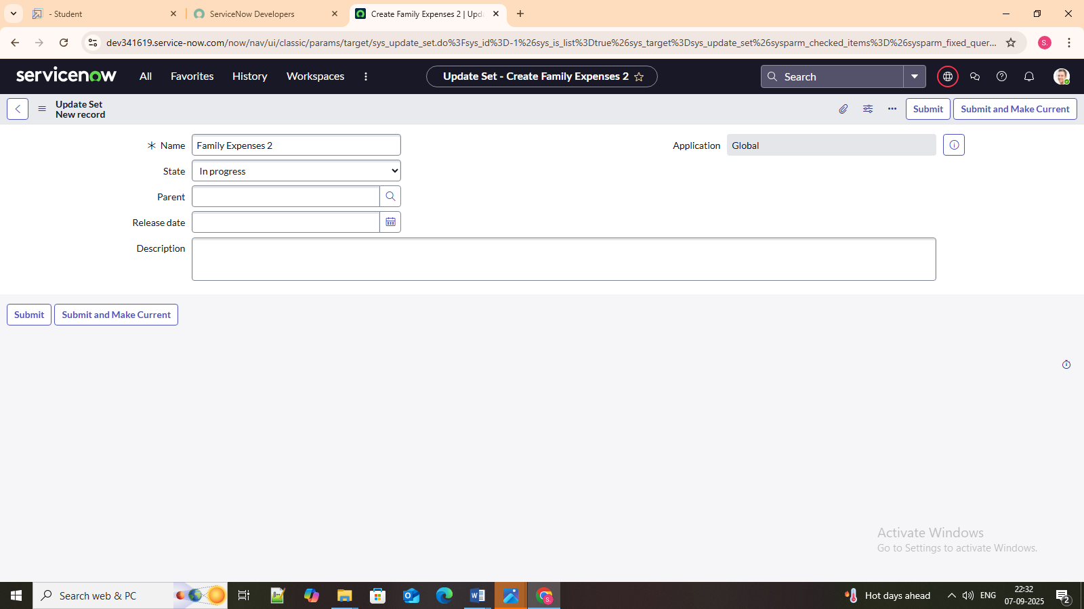

- Enter the Details as:
Name: Family Expenses
- Then click on Submit and Make current.

Milestone 3: creation of tables

Activity 1: Creation of Family Expenses Table

- Go to All > In the filter search for Tables > click on New.
- Enter the Details:
Label: Family Expenses
Name: Auto-Populated
New menu name: Family Expenditure

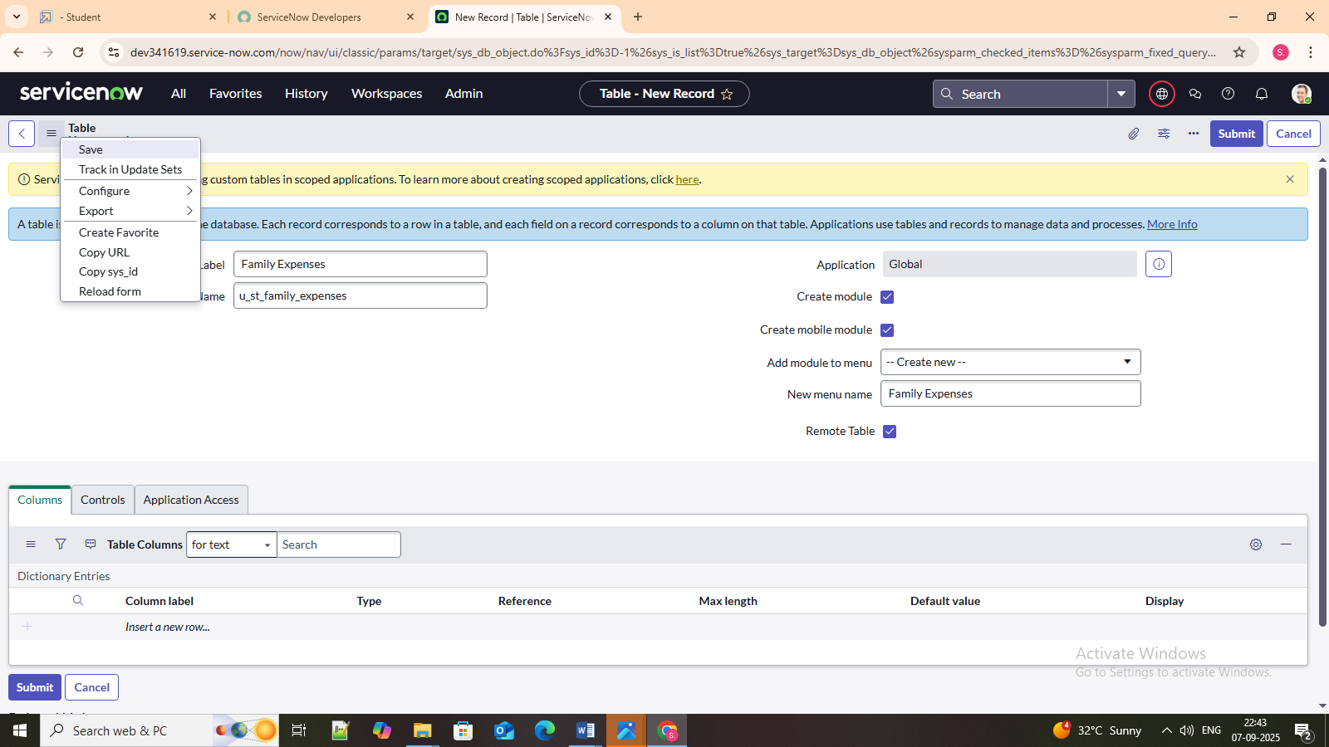

3. Go to the Header and right click there>> click on Save

Activity 2: Creation of Columns (Fields)
1. Near Columns Double click near insert a new row.

2. Give the details as:
Column label: Number
Type: String
- Double clicks on insert a new row again
- Give the details as:
Column label: Date
Type: Date
- Double clicks on insert a new row again
- Give the details as:
Column label: Amount
Type: Integer
- Double clicks on insert a new row again
- Give the details as:
Column label: Expense Details
Type: String
Max length: 800
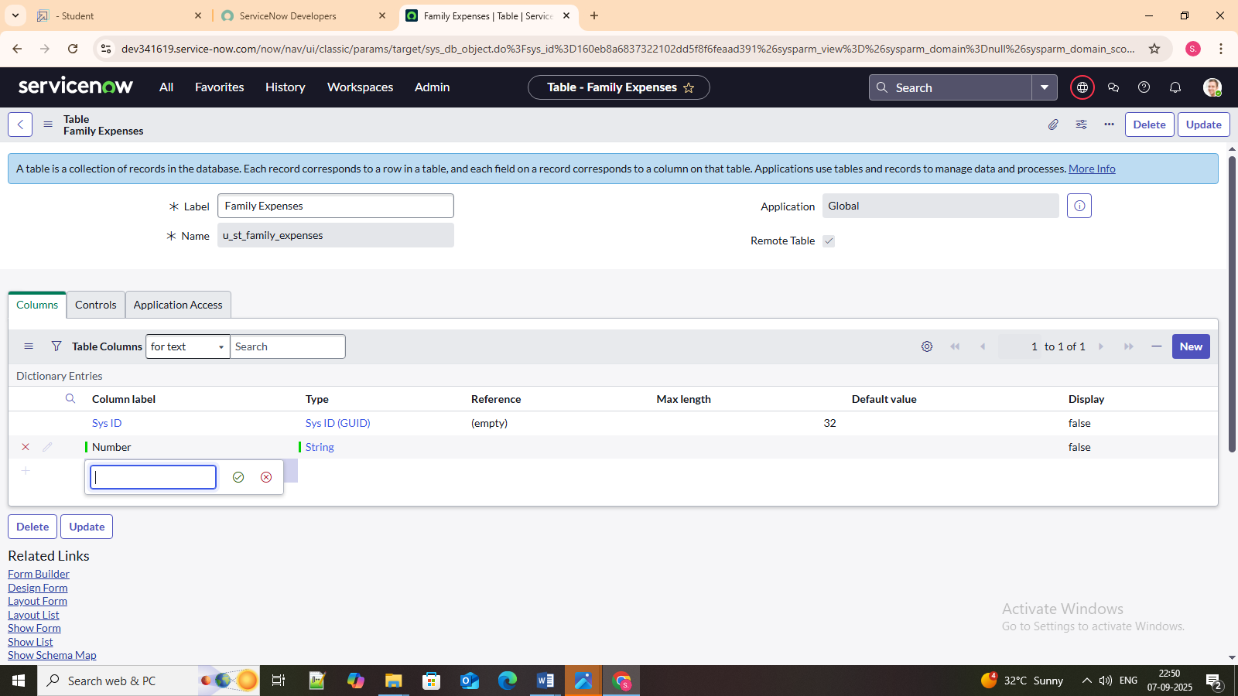

9. Go to the Header and right click there>> click on Save

Activity 3: Making Number Field an Auto-Number
- Double clicks on the Number Field/Column.
- Go down and double click on Advanced view
- In Default Value:
Use dynamic default: check the box
Dynamic default value: Get Next Padded Number
- Click on Update.

- Go to All >> In the filter search for Number Maintenance >> select Number Maintenance
- Click on New.
- Enter the below Details:
Table: Family Expenses
Prefix: MFE

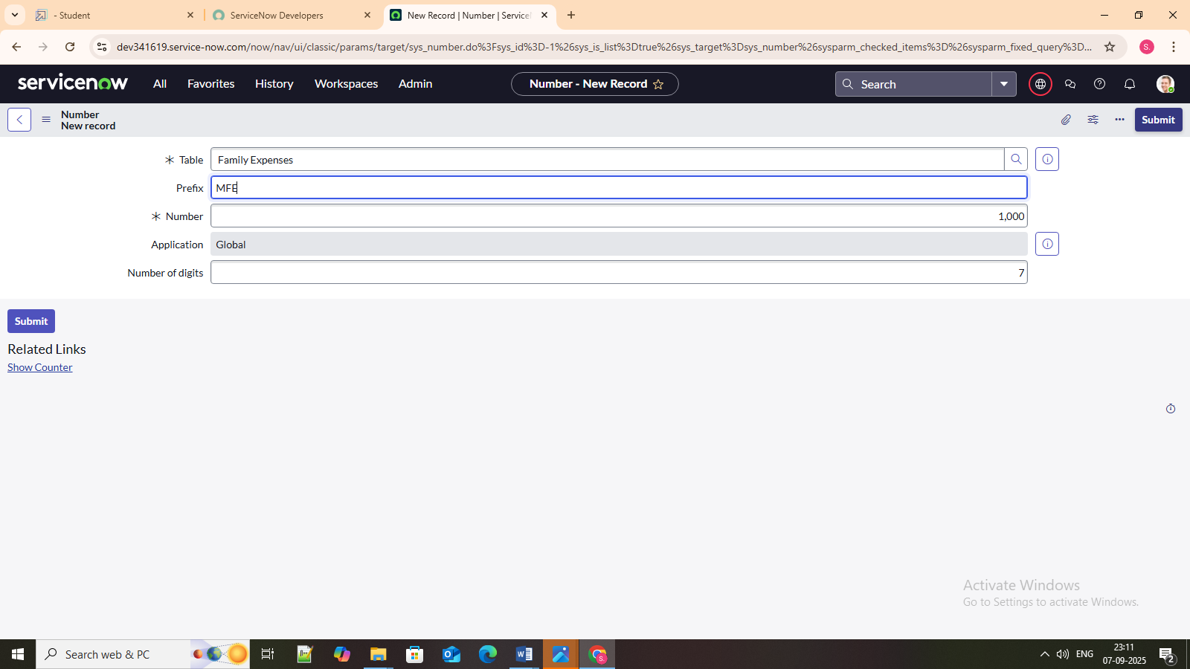

- Click on Submit.
Activity 4: Configure the Form

- Go to All >> In the filter search for Family Expenses >> Open Family Expenses
- Click on New
- Go to the Header and right click there>> click on Configure >> Select Form Design
- Customize or Drag Drop the form as per your requirement.

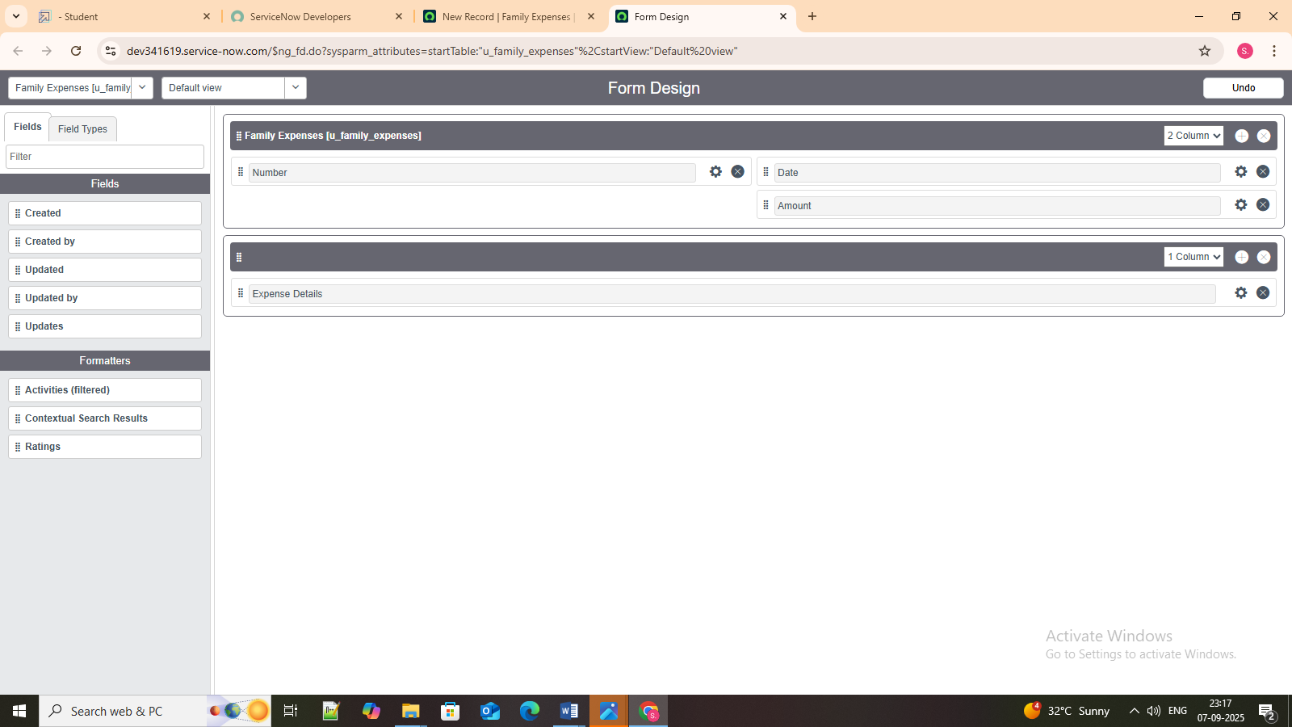
- Make Number Read-Only Field by clicking on the gear icon and checking Read-Only
- Make Date, Amount Mandatory Field by clicking on the gear icon and checking Mandatory
- Click on Save.

Milestone 4: Creation of Table (Daily Expenses)

Activity 1: Creation of Daily Expenses Table

- Go to All > In the filter search for Tables > click on New.
- Enter the Details:
Label: Daily Expenses
Name: Auto-Populated
Add Module to menu: Family Expenditure

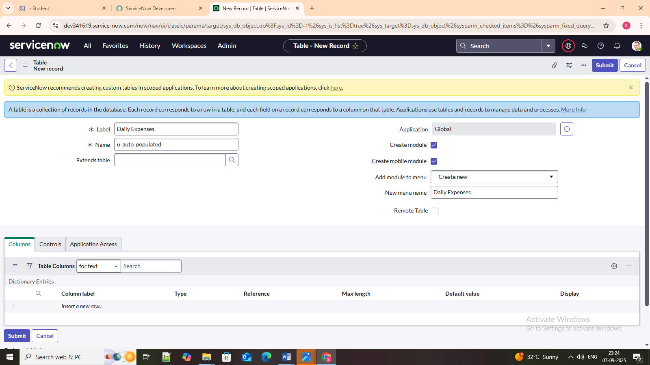

- Go to the Header and right click there>> click on Save.

Activity 2: Creation of Columns (Fields)
- Near Columns Double click near insert a new row.
- Give the details as:
Column label: Number
Type: String
- Double clicks on insert a new row again
- Give the details as:
Column label: Date
Type: Date
- Double clicks on insert a new row again
- Give the details as:
Column label: Expense
Type: Integer
- Double clicks on insert a new row again
- Give the details as:
Column label: Family Member Name
Type: Reference
Max length: 800
- Double clicks on insert a new row again
- Give the details as:
Column label: Comments
Type: String
Max length: 800
- Go to the Header and right click there>> click on Save.

Activity 3: Making Number Field an Auto-Number
- Double clicks on the Number Field/Column.
- Go down and double click on Advanced view
- In Default Value:
Use dynamic default: check the box
Dynamic default value: Get Next Padded Number
- Click on Update.


- Go to All >> In the filter search for Number Maintenance >> select Number Maintenance
- Click on New.
- Enter the below Details:
Table: Family Expenses
Prefix: MFE

Activity 4: Configure the Form

- Go to All >> In the filter search for Daily Expenses >> Open Daily Expenses
- Click on New
- Go to the Header and right click there>> click on Configure >> Select Form Design
- Customize or Drag Drop the form as per your requirement.


- Make Number Read-Only Field by clicking on the gear icon and checking Read-Only
- Make Date, Family Member Name Mandatory Field by clicking on the gear icon and checking Mandatory
- Click on Save.

Milestone 5: Creation of Relationship

Activity 1: Creation of Relationship between Family Expenses and Daily Expenses tables
- Go to All >> In the filter search for Relationships >> Open Relationships
- Click on New.
- Enter the details:
Name: Daily Expenses
Applies to table: Select Family Expenses
Daily Expenses: Select Daily Expenses
- Click Save.

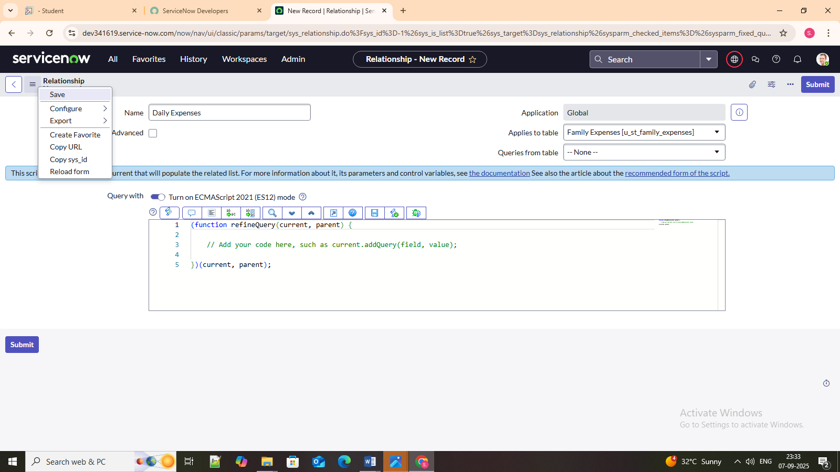

Milestone 6: Configuring Related List on

Family Expenses

Activity 1: Configuring Related List on Family Expenses
- Go to All >> In the filter search for Family Expenses >> Open Family Expenses
- Click on New
- Go to the Header and right click there>> click on Configure >> Select Related Lists
- Add Daily Expenses to the Selected Area.
- Click on Save
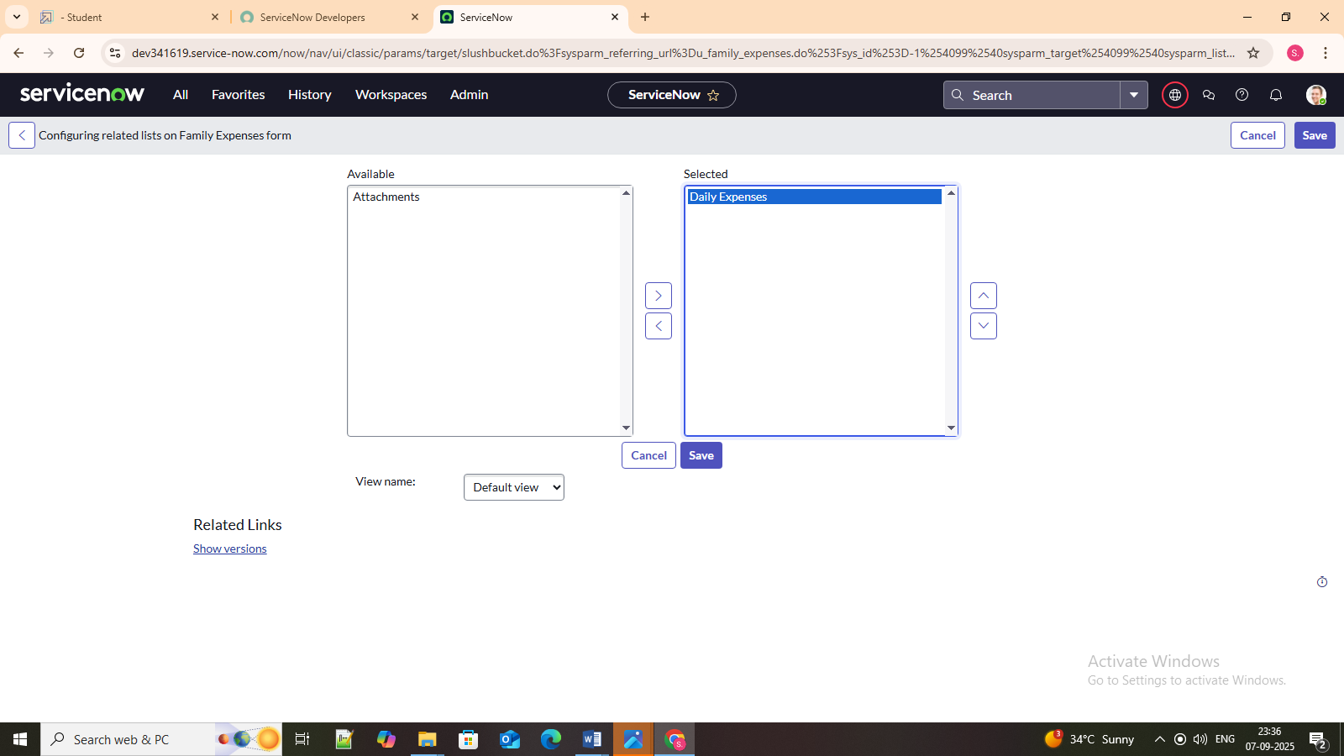

Milestone 7: Business rules

Activity 1: Creation of Business Rules
- Go to All >> In the filter search for Business Rules.
- Under System Definition Select Business Rules then click on New.
- Enter the Details:
Name: Family Expenses BR
Table: Select Daily Expenses
Check Advanced

- In when to run Check Insert and Update
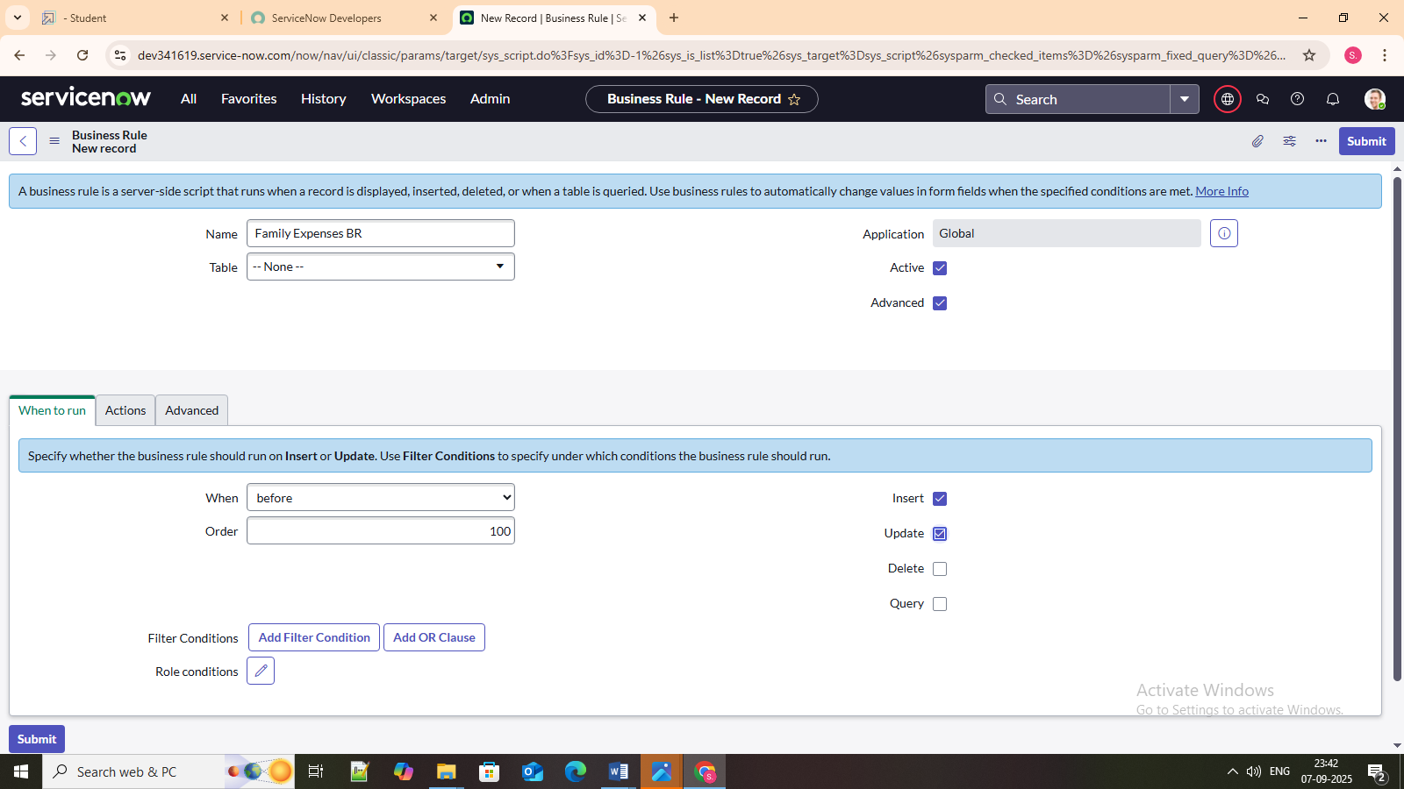

- In Advance (we write the code): Write the below code >>

(function executeRule(current, previous /*null when async*/) {

var FamilyExpenses = new GlideRecord('u_family_expenses');
FamilyExpenses.addQuery('u_date',current.u_date);
FamilyExpenses.query();
if(FamilyExpenses.next())
{
FamilyExpenses.u_amount += current.u_expense;
FamilyExpenses.u_expense_details += ">"+current.u_comments+":"+"Rs."+current.u_expense+"/-";
FamilyExpenses.update();
}
else
{
var NewFamilyExpenses = new GlideRecord('u_family_expenses');
NewFamilyExpenses.u_date = current.u_date;
NewFamilyExpenses.u_amount = current.u_expense;
NewFamilyExpenses.u_expense_details += ">"+current.u_comments+":"+"Rs."+current.u_expense+"/-";
NewFamilyExpenses.insert();
}

})(current, previous);

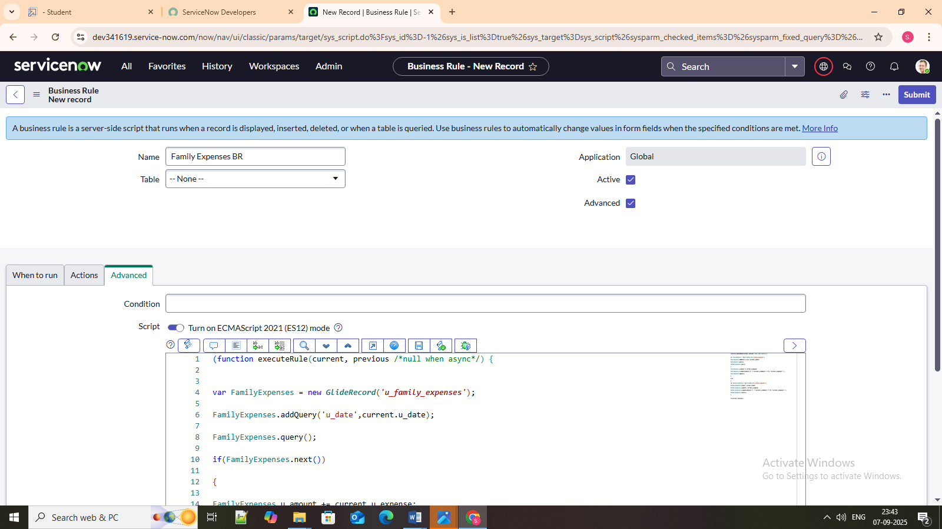
- Go to the Header and right click there>> click on Save.

Milestone 8: Relationship Configuration

Activity 1; Configure the Relationship
- Go to All >> In the filter search for Relationships >> Open Relationships.
- In that, open Daily Expenses Relationship.
- For Applies to table: Select Family Expenses.
- In Query with: write the below Query.

(function refineQuery (current, parent) {

// Add your code here, such as current. addQuery(field, value);
current.addQuery('u_date',parent.u_date);
current.query();

})(current, parent);

- Click on Update.
